Issue # 16 ONLY25¢

PBJ TIMES© “DELIVERED EVERY FRIDAY”

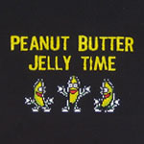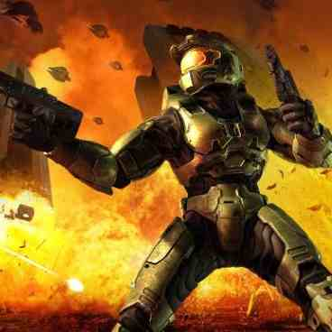
Yes! I won! In your face! In…your…face! Master chief is Ballin, and you guys are fallin, cuz if you be up in my grille, I’ll take you all down one… by… one!

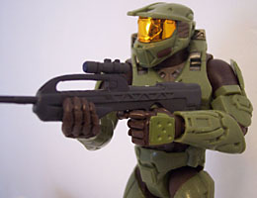

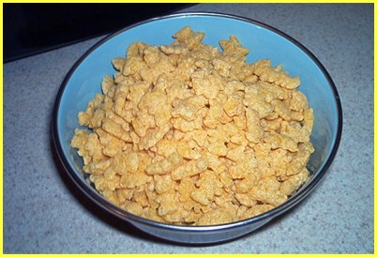

Stay tuned, for next week, and watch Master Chief take off his helmet! Be prepared for a surprising twist!

EVENTS
- 11/2 Two new Co-authors!
- 11/2 Find out how the PBJ TIMES all began by visiting the about page on the new website!
- 11/16 There will be no PBJ TIMES on this date because of the Washington DC field trip.

…………………………………………………………

Oh, don’t be a party pooper… lighten up! I creamed you with whipped topping! Then I put on some fudge, sprinkles, a bit of coco powder, extra marshmallows, Oreo bits, and then put a cherry on top! Then I took my bib, spoon and…

OK WE GET IT YOU WON… MY LIFE IS OVER AND THERE IS NO REASON FOR ME TO LIVE! HAPPY NOW?

YAY! Say more! Again, again! I couldn’t hear to well with my mask on… Just a bit louder… say that I won…

Well, its not that fair… I mean I don’t have any hands…
Author- Matthew Szewczyk ☺
Co-author- Peyton Martinez ☹
Advisor- Aaron Pirko
Copyright®2007 PBJ TIMES co.
Questions? Feel free to E-mail: matthew.szewczyk@verizonmail.com

All these excuses… besides, the less arms you have, the funnier it is to kill you! You guys are just jealous.

Jealous? Take off your helmet and face us like a man! I declare a rematch!
Come check out
Matt’s Myspace!
My URL
myspace.com/supremecookieman

CONTENTS
Page 1- Newz/Eventz
Page 2- Laugh out loud’z
Page 3- Comicz
Page 4- More Comicz
Page 5-Adz/Nincompoopz corner

Come check out
Matt’s Website!
My Website
pbjtimes.wordpress.com
Who won the fight?
Your votes are in! You no longer have to wait! Your life will now be complete! The winner of the Halo 3 fight is… Continued on Page 4!

LAUGH-OUT-LOUD’S!

My Son Master Chief and his three friends are telling stories in a bar. Master Chief leaves for a bathroom break. Three guys are left. The first guy says, "I was worried that my son was gonna be a loser because he started out washing cars for a local dealership. Turns out that he got a break, they made him a salesman, and he sold so many cars that he bought the dealership. In fact, he’s so successful that he just gave his best friend a new Mercedes for his birthday." The second guy says, "I was worried about my son too because he started out raking leaves for a Realtor. Turns out he got a break, they made him a commissioned salesman, and he eventually bought the real estate firm. In fact, he’s so successful that he just gave his best friend a new house for his birthday." The third guy says, "Yeah, I hear you. My son started out sweeping floors in a brokerage firm. In fact, he’s so rich that he just gave his best friend a million in stock for his birthday." Master Chief comes back from the can. The first 3 explain that they are telling stories about their kids, so he says, "Well, I’m embarrassed to admit that my son is a MAJOR disappointment. He started out as a hairdresser and is STILL a hairdresser after 15 years. In fact, I just found out that he’s gay and has SEVERAL boyfriends. But, I try to look at the bright side his boyfriends just bought him a new Mercedes, a new house, and a million in stock for his birthday."
Freezer One day Master Chief dies and goes to heaven. He meets a guy up their named Phil. One day Phil says: " Master Chief, how did you die?" Master Chief said: "I froze to death. What about you?" Phil says: " I thought my wife was cheating on me so I searched the whole house to find a guy. When I didn’t find the guy, I had a heart attack and died." Master Chief says: " Oh way to go! If u had checked the freezer, we both would have been alive now!"
The Bet A guy that was in the bar for a while goes up to the bartender and says "you see that cup over there?" (Pointing to a small cup behind the counter) "Ill bet you $100 that I can stand on that table over there" (pointing to a table at the far end of the bar) "and pee so that it gets into that cup." The bartender smiles and agrees to the offer, cause, you know, he’s thinking easy money. So the guy goes and stands on the table, does his thing and starts spinning around in circles, completely missing the cup. The whole time the bartender is smiling, thinking about the money. So the guy finishes and goes to the bartender, smiling. The bartender said, "Why are you smiling? You just lost $100." The guy looked at the bartender and said "yeah, well, you see those guys over there? I bet them $1000 that I could pee all over your bar, and you’d be smiling."

COMICS
(Comics selected from www.redvsblue.com)
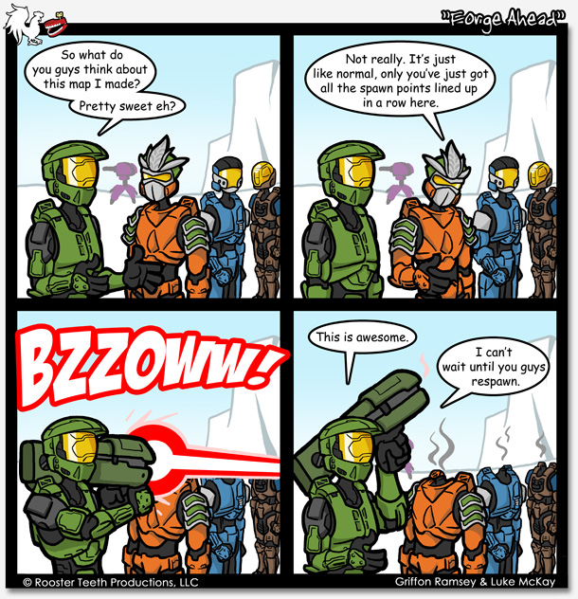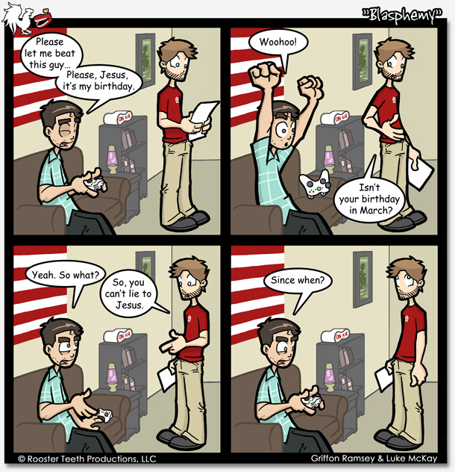

MORE COMICS!
(Comics selected from www.redvsblue.com)
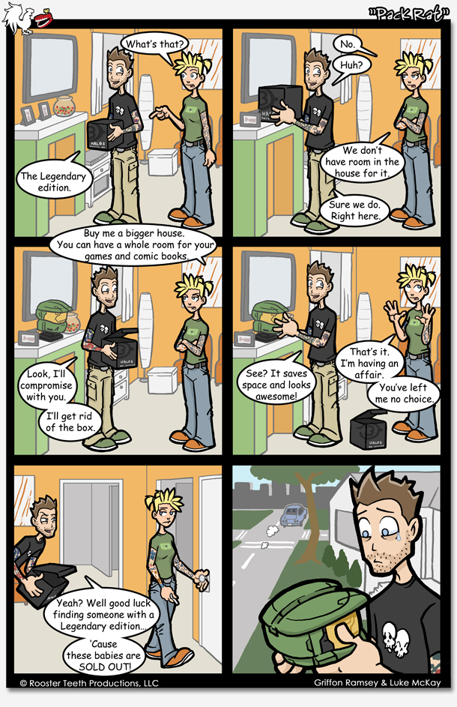

Poll Results Are In!
The unofficial winner of the Halo 3 fight, decided by none other then you is…(pause)…(drum roll)…(another pause)… Master Chief with 100% of your votes!

ADVERTISMENTS
NINCOMPOOP CORNER
Are you or someone you know a true nincompoop? Become apart of this section and reveal your inner nincompoop. Do something dumb so everyone can laugh at you! Pretty sweet deal to me!
Aaron- Let go of measuring tape and the sharp end cut my thumb open.
Bijan- For thinking he can beat me in air hockey.
Caleb- Him and me tied four times in row while playing speed.
Matt- I IM’d Aaron and caused him to lose all progress in his online game.
Joey- One of his satellites are out of orbit.

PH

Ads (FAKE!)
Master chief got some skills!
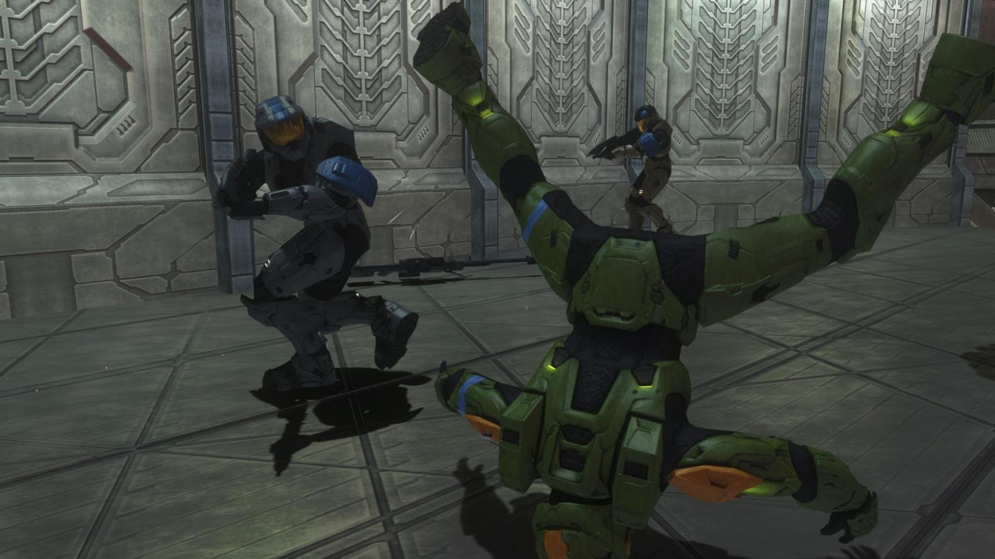
Cough…you’ll gas the aliens out if you keep that up!
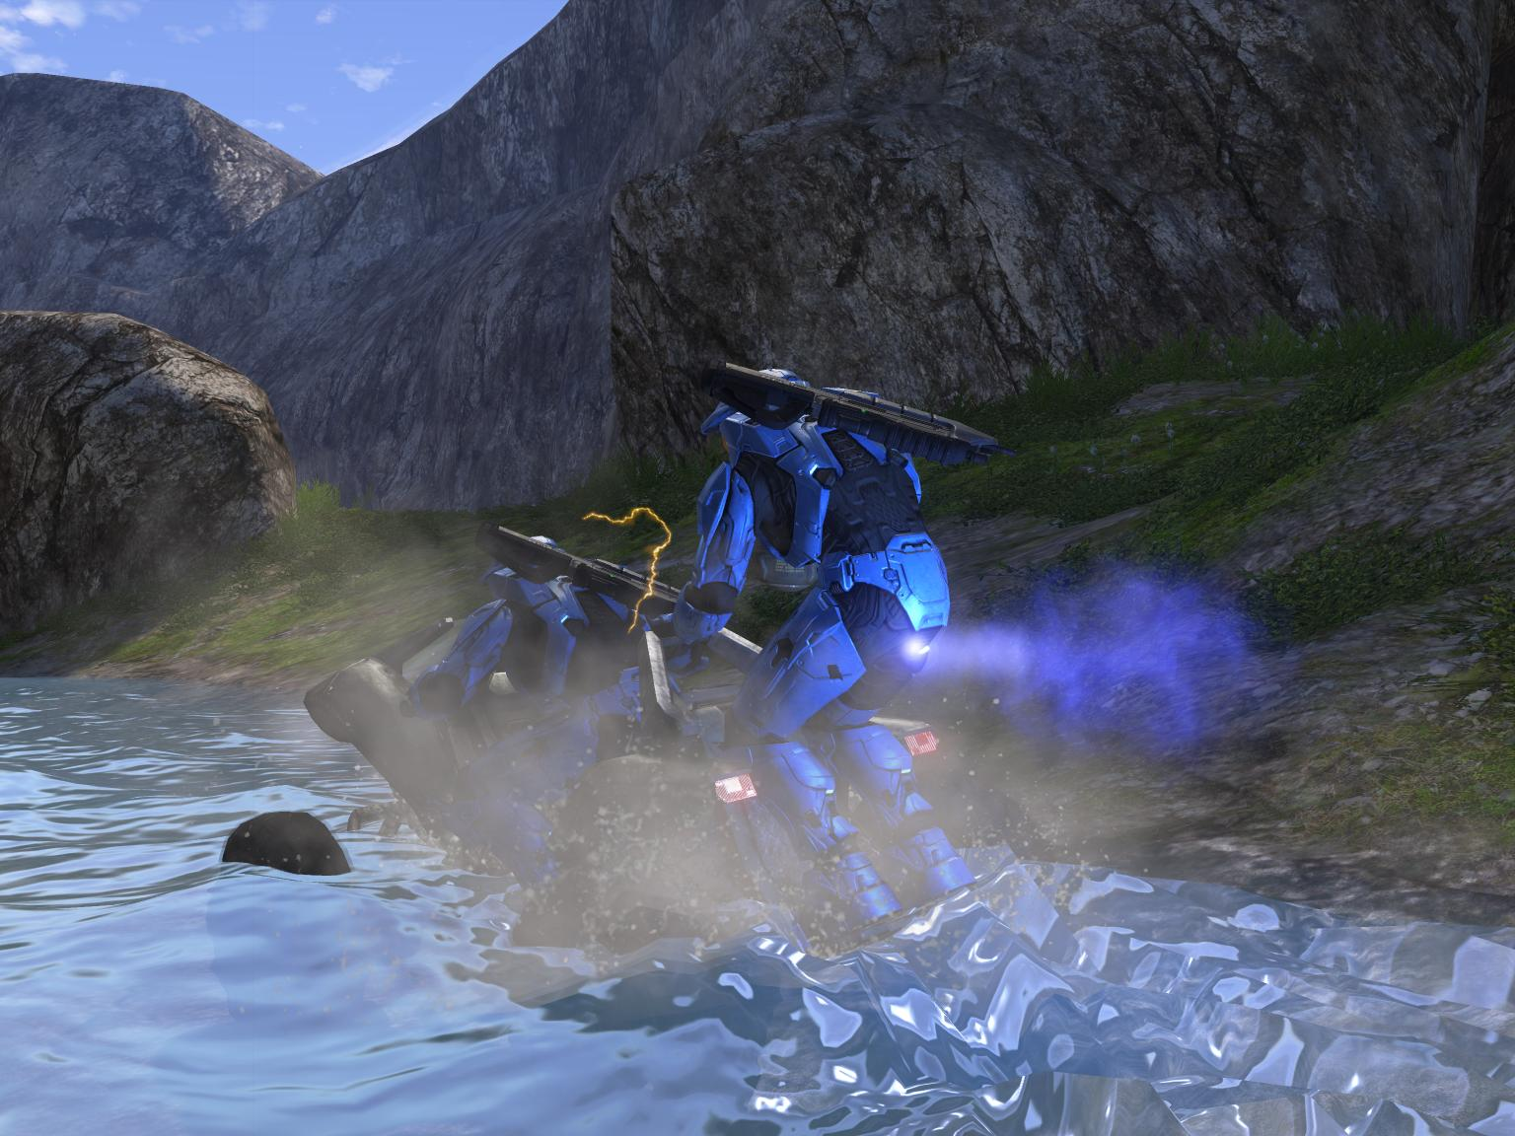
Um… master chief… you got a little… a little thing stuck in your head… I think it’s not going to be a problem though…
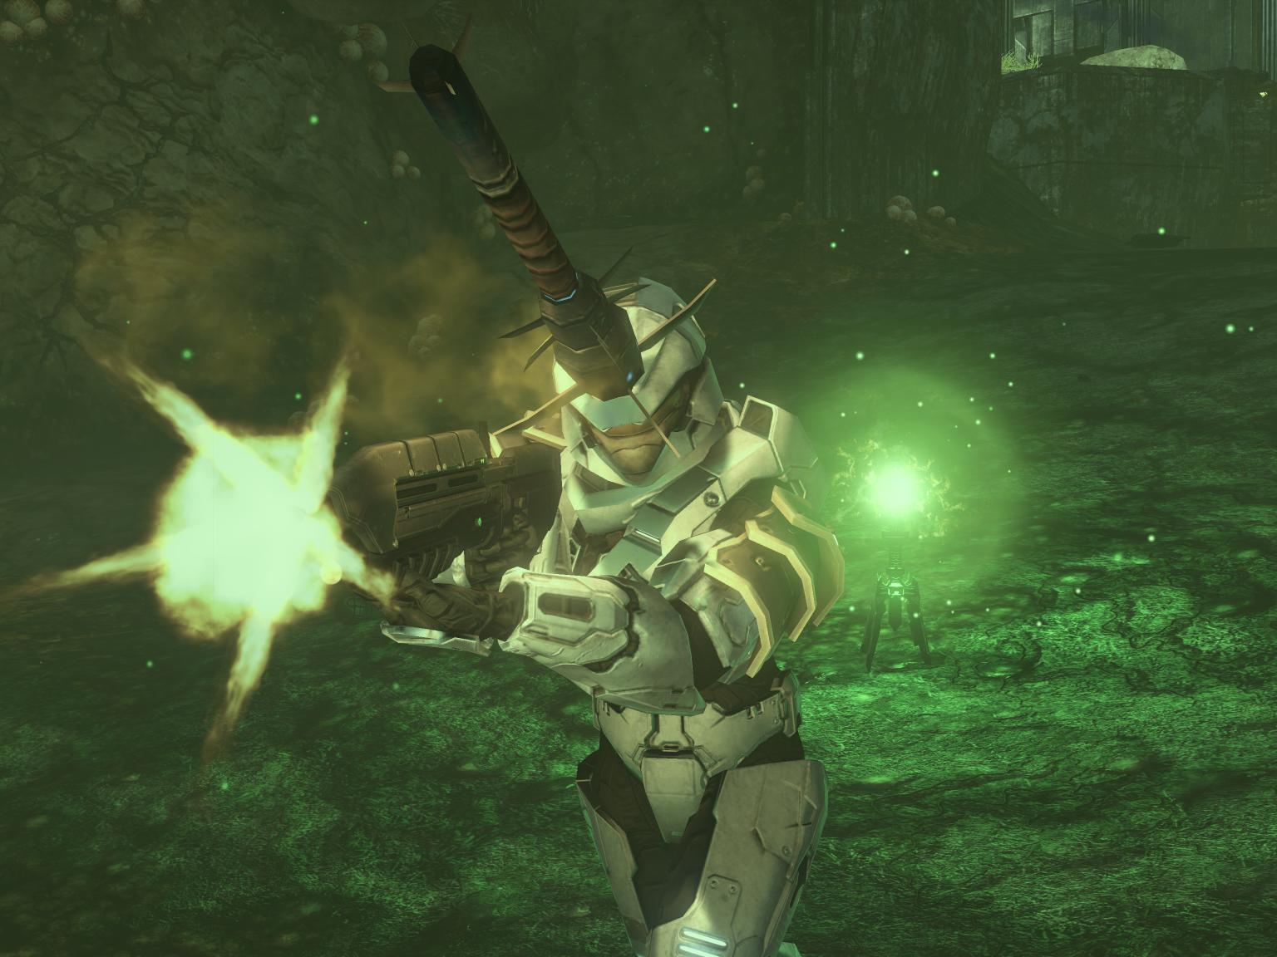



Word of wisdom for the week

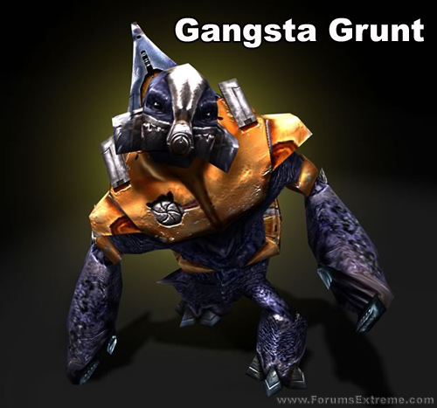
Just stay away from this guy… you don’t want any trouble…

YOUR FREE AD COULD BE HERE!


Do you have questions? Comments? Advice? Ads? Comics? Funny Pics? Then send them to PBJ TIMES (Matt) for approval. Any ideas or donations will be greatly appreciated. I need your help! Thanks!
This magazine is not a joke! It will be free every Friday until the end of the year. The newspaper is constantly changing! The polls, contests, prizes, nincompoops, & people are real! So do your part! Participate! Without you this newspaper is not possible! Thank you for choosing the PBJ Times as your number one comedy newspaper again!

 =
Milk and cereal monster
Monsters have come to steal our beloved PBJ!
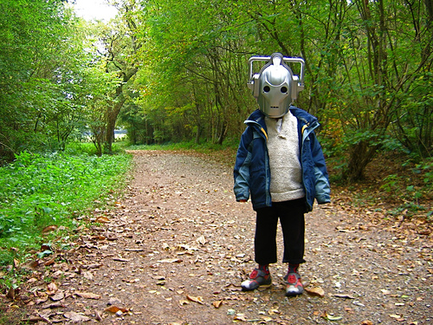
You’ve been warned!
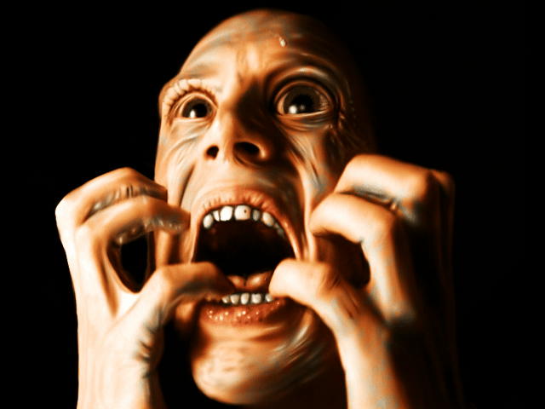

Scared face

