Issue # 16 ONLY25¢

PBJ TIMES© “DELIVERED EVERY FRIDAY”

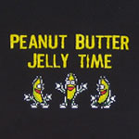
You want a rematch? You got it! Milk and cereal… you should just save yourself the embarrassment of losing and grow some hands or go home…

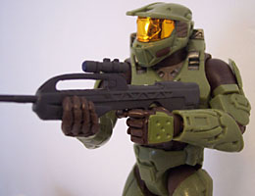

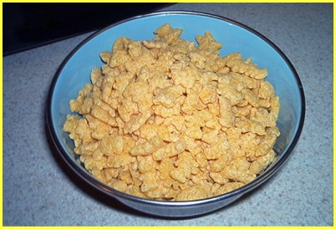



EVENTS
- 11/16 (next week) IMPORTANT! There will be no PBJ TIMES on this date because I’m going on the Washington DC field trip.
- 11/23 There will be an issue on this date!
- 11/23 Will be a mystery special edition! YAY!

Fine! I’ll just play guitar hero at my apartment instead….

Ya… sure buddy…you try that…

OK, lets get down to business… first of all we agreed you would take off your mask…

Trust me … you don’t want me to take off my mask… it will disappoint everyone… just let me be…

I bet you’re so ugly that when you walk down the street in September, people say "Wow, is it Halloween already?"


That’s it! You asked for it…
Author- Matthew Szewczyk ☺
Co-author- Peyton Martinez ☺
Editor- Aaron Pirko ☺
PBJ TIMES Copyright® 2007
Questions? Feel free to E-mail: matthew.szewczyk@verizonmail.com

OMG Milk and cereal monster! AHH!

BAM!
Come check out
Matt’s Myspace!
My URL
myspace.com/supremecookieman

To be continued…?

CONTENTS
Page 1- Newz/Eventz
Page 2- Laugh out loud’z
Page 3- Comicz
Page 4-Adz/Nincompoopz corner

Come check out
Matt’s Website!
My Website
pbjtimes.wordpress.com
The PBJ TIMES’s website has almost reached 3,000 hits! Unfortunately I am going to DC next week, so there won’t be any issue next week…

LAUGH-OUT-LOUD’S!

The Guys’ Rules
These are the mens rules for women (They are all numbered one for a reason!) 1. Men are NOT mind readers. 1. Sunday sports. It’s like the full moon or the changing of the tides. Let it be. 1. Shopping is NOT a sport. And no, we are never going to think of it that way. 1. Ask for what you want. Let us be clear on this one: Subtle hints do not work! Strong hints do not work!
Obvious hints do not work! Just say it! 1. Yes and No are perfectly acceptable answers to almost every question. 1. A headache that lasts for 17 months is a Problem. See a doctor. 1. Anything we said 6 months ago is inadmissible in an argument. In fact, all comments become null and void after 7 Days. 1. If you won’t dress like the Victoria’s Secret girls, don’t Expect us to act like soap opera guys. 1. If something we said can be interpreted two ways and one of them makes you sad or angry, then we meant the other one. 1. Christopher Columbus did NOT need directions and neither do we. 1. ALL men see in only 16 colors, like Windows default settings. Peach, for example, is a fruit, not a color. Pumpkin is also a fruit. We have no idea what mauve is. 1. If it itches, it will be scratched. We do that. 1. If we ask what is wrong and you say “nothing,” We will act like nothing’s wrong. We know you are lying, but it is just not worth the hassle, besides we know you will bring it up again later. 1. If you ask a question you don’t want an answer to, Expect an answer you don’t want to hear.
1. When we have to go somewhere, absolutely anything you wear is fine… Really.
1. Don’t ask us what we’re thinking about unless you are prepared to discuss such topics as baseball, the shotgun formation, or golf.
1. You have enough clothes.

COMICS

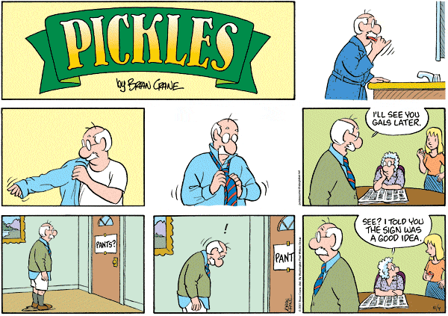

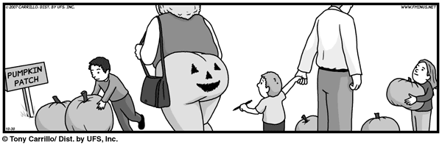
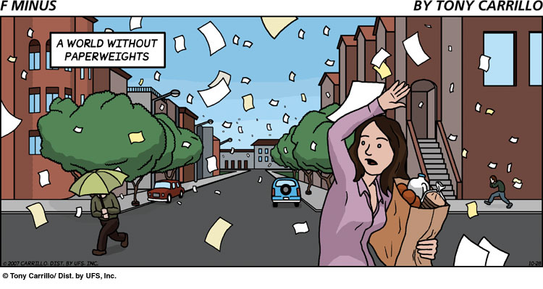

ADVERTISMENTS
NINCOMPOOP CORNER
Are you or someone you know a true nincompoop? Become apart of this section and reveal your inner nincompoop. Do something dumb so everyone can laugh at you! Pretty sweet deal to me!
Werther- Threw a pencil at my face
Werther- Made extremely inappropriate noises in class
Werther- For using highly technical terms in everyday language
Werther- For taking up almost all the space in the nicompoops corner
Joey- For playing random peoples instruments

PH

Ads (FAKE!)
Word of wisdom for the week
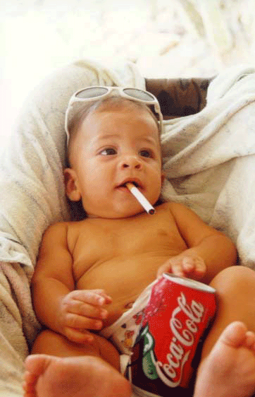
Laziness can start at any age…
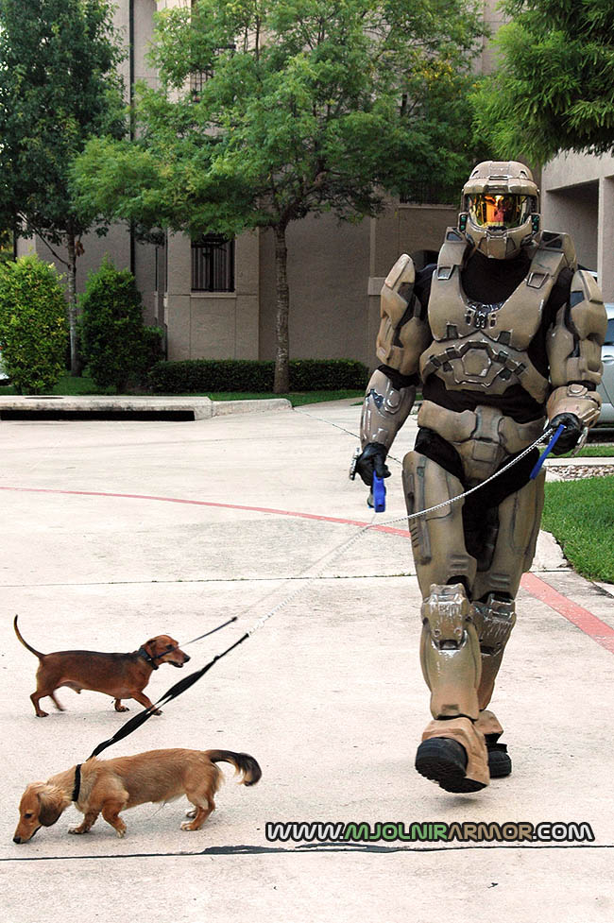
Master Chiefs Dog walking Service!
Only $1000 a day!
Not only do we have food, we also have a terrorist free playplace!*
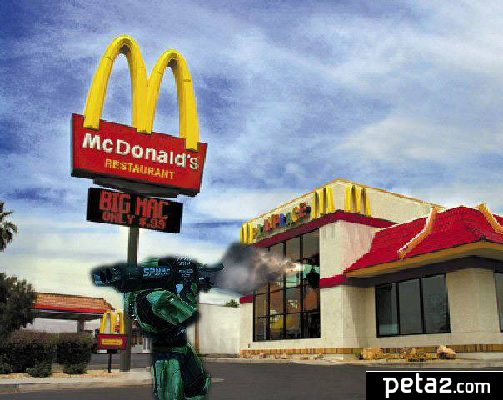
*Until Master Chief came for an iced tea



Remember there is no PBJ TIMES next week! And thanks for making 3000 hits on the website!

Do you have questions? Comments? Advice? Ads? Comics? Funny Pics? Then send them to PBJ TIMES (Matt) for approval. Any ideas or donations will be greatly appreciated. I need your help! Thanks!
This magazine is not a joke! It will be free every Friday until the end of the school year. The newspaper is constantly changing! The polls, contests, prizes, nincompoops, & people are real! So do your part! Participate! Without you this newspaper is not possible! Thank you for choosing the PBJ Times as your number one comedy newspaper again!
YOUR FREE AD COULD BE HERE!

 =
Milk and cereal monster



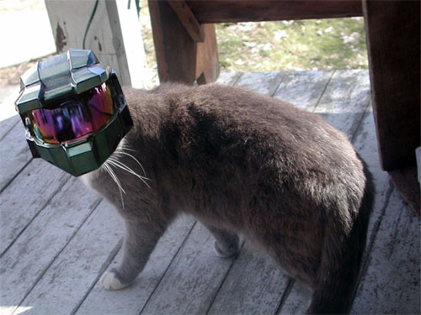
Master Chief in his second life…

